Project Design Phase-II
Data Flow Diagram & User Stories

Date | 19 February 2026
Team ID | LTVIP2026TMIDS81333
Project Name | ShopSmart: Your Digital Grocery Store Experience
Maximum Marks | 4 Marks

Data Flow Diagrams:
A Data Flow Diagram (DFD) is a traditional visual representation of the information flows within a system. A neat and clear DFD can depict the right amount of the system requirement graphically. It shows how data enters and leaves the system, what changes the information, and where data is stored.
Example: DFD Level 0 (Industry Standard)

Example: (Simplified)
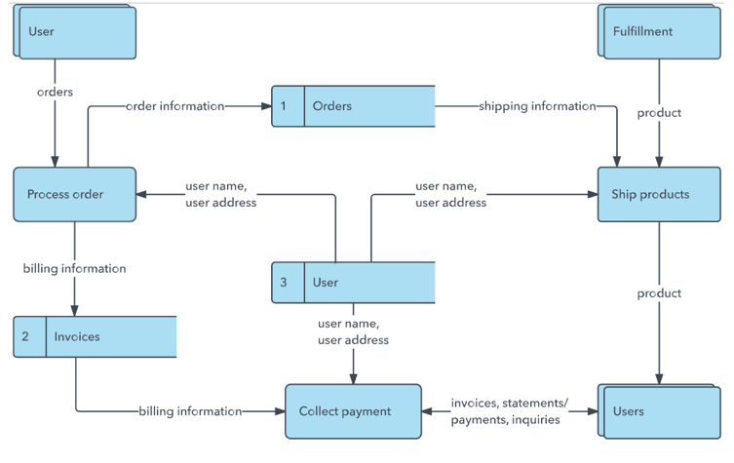


User Stories
Use the below template to list all the user stories for the product.
User Type | Functional Requirement (Epic) | User Story No. | User Story / Task | Acceptance Criteria | Priority | Release
Customer (Web user) | User Authentication | USN-1 | As a user, I can register with name, email, and password | Valid email and password required. User account created successfully. | High | Sprint-1
 |  | USN-2 | As a user, I can log in using my registered credentials. | Only valid credentials allow access. Error shown for invalid login. | High | Sprint-1
 |  | USN-3 | As a user, I can view all grocery products. | Products displayed with image, price, and category. | High | Sprint-1
 |  | USN-4 | As a user, I can search and filter products. | Search results update dynamically. | Medium | Sprint-2
Customer (Web user) | Cart & Orders | USN-5 | As a user, I can add products to cart | Items added with correct quantity and total price calculation. | High | Sprint-2
 |  | USN-6 | As a user, I can remove or update items in cart. | Cart updates instantly and recalculates total | Medium | Sprint-3
 |  | USN-7 | As a user, I can place an order. | Order stored in database and confirmation displayed | High | Sprint-3
 |  | USN-8 | As a user, I can view order history. | Previous orders displayed with status.. | Medium | Sprint-4
Administrator | Product Management | USN-9 | As an admin, I can add new grocery products. | New products saved in database and visible to users. | High | Sprint-2
 |  | USN-10 | As an admin, I can update or delete products. | Changes reflect immediately in product listing. | High | Sprint-3
 | Order Management | USN-11 | As an admin, I can view all customer orders. | Admin panel displays order details and status. | Medium | Sprint-3
 |  | USN-12 | As an admin, I can update order status (Processing, Shipped, Delivered). | Updated status visible to customer instantly. | Medium | Sprint-4

